SIMATS ENGINEERING
ASSESSMENT TOOL 3-Flow chart to Code Conversion

COURSE NAME: Data Structures COURSE CODE: CSA03

COURSE OUTCOME COVERED

CO5: Construct MST using shortest path algorithms and traverse the graph to model and analyse real-world problem. (Bloom Level -BL4, BL6)

Assessment Tool Weightage: 35%

QUESTIONS: EACH QUESTION CARRIES: 10 MARKS DURATION: 1 HOUR

- A flowchart implements a queue using an array with ENQUEUE and DEQUEUE operations. Convert it into C code.

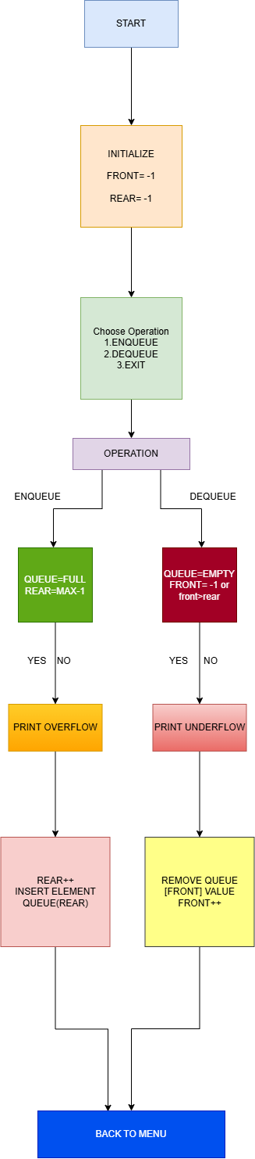

- Convert a flowchart for implementing Kruskal’s Algorithm into a C program.

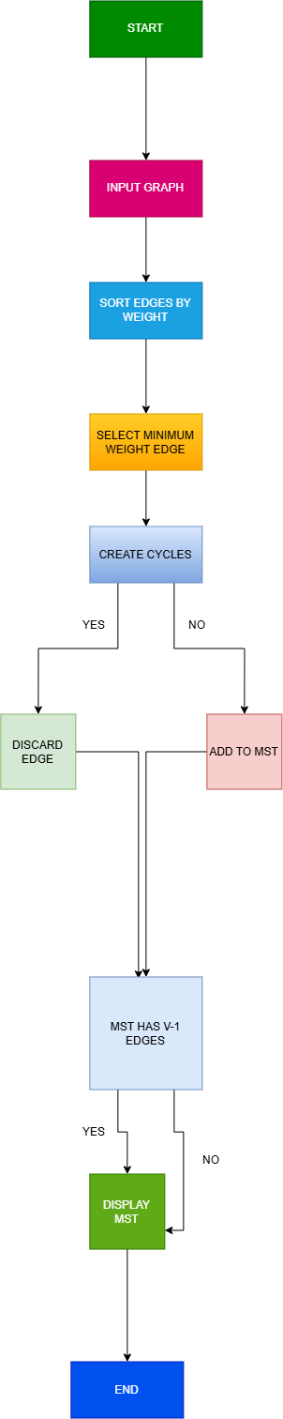

Rubrics:

S. No. | Rubric | Weightage | Excellent (4) | Good (3) | Satisfactory (2) | Needs Improvement (1)
1 | Flowchart Interpretation | 20% | Correctly understands all flowchart symbols, logic, and sequence | Minor interpretation errors | Understands basic flow | Misinterprets major parts
2 | Code Correctness | 30% | Code accurately implements the complete flowchart logic | Minor coding errors | Partially implements the logic | Major logic errors
3 | Control Structures & Logic | 20% | Correctly uses conditions, loops, and sequences | Minor errors in control structures | Basic structures used with errors | Incorrect or missing structures
4 | Output & Testing | 15% | Produces correct output for all test cases and handles edge cases | Correct for most test cases | Correct for basic cases | Incorrect output in most cases
5 | Code | 15% | Code accurately implements the complete flowchart logic | Minor coding errors | Partially implements the logic | Major logic errors

